PROJECT PROPOSAL

NIHVA TECHNOLOGIES PVT. LTD.
187, G-Block, Thermax chowk, Above Renault Showroom, MIDC
Chinchwad, Pune – 411019.

CUSTOMER NAME | ORDNANCE FACTORY DEHUROAD
OFFICE ADDRESS | ORDNANCE FACTORY, DEHU ROAD, MAHARASHTRA 412101
PROJECT LOCATION | ORDNANCE FACTORY DEHUROAD
CONTACT PERSON NAME | MR. T.K PANDA  ENGINEERING HEAD
EMAIL ID | ofdreo.ofb@nic.in
CONTACT NUMBER | +91 9422009885

Contact Person: Mr. Mayur Derle
Mob No.: 7709209333
Web: http://www.nihva.com

AUTOMATION SOLUTION-DIVISION

Ordnance Factory

Title: Augmenting Charges Filler Machine

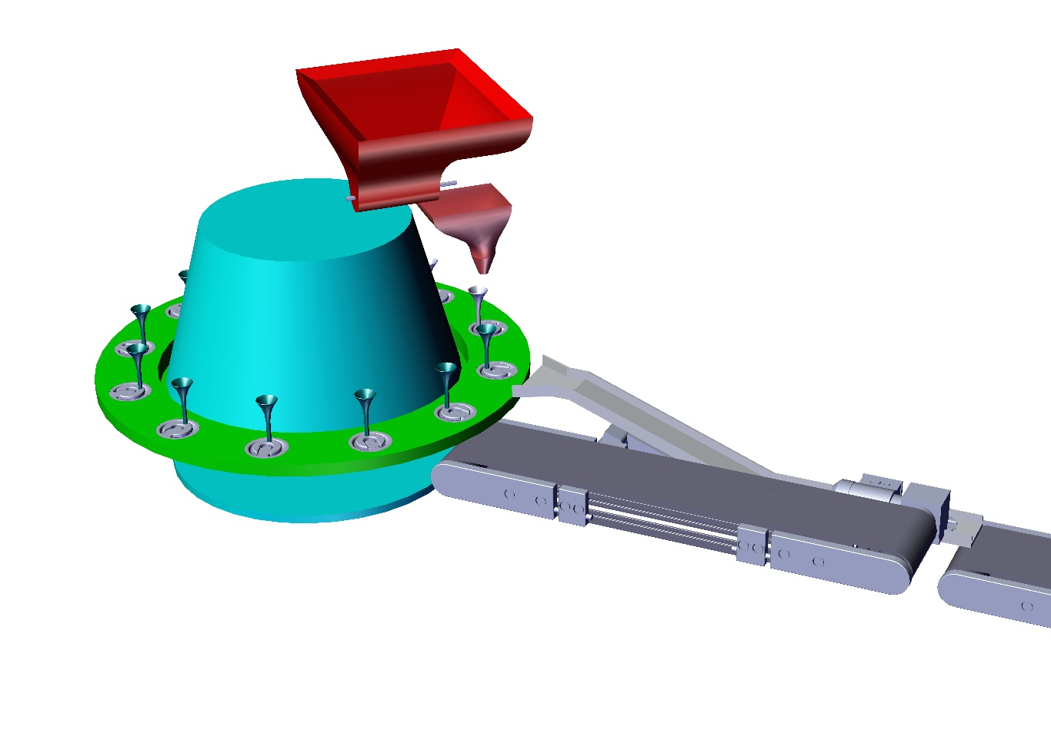

Date: 08.09.2017

To,

Ordnance Factory
Dehuroad, Pune-412101

Kind Attention: Mr. T.K. PANDA

Dear Sir,

Thank you for giving us an opportunity to participate with our offer on the above project. We enclose here with our proposal includes:

- Requirement
- Scope of Works
- Drawing, Training & warranty
- Details of Application
- Commercial
- Technical Specification
- Terms & conditions

- Requirement
- Energy efficient Design: The system should be energy efficient. The design shall ensure minimum possible power.
- Reduced Manpower: In this process only few things are done by workers and all the heavy operation will have done by machine automatically. So this system will require minimum labour work.

- Scope of work:

The scope of work shall be exclusively on Augmenting Filler Machine.

For the above scope, following set of activities are expected to be performed:

- First augmenting Charges will load into the magazine unit.
- Then load all the flakes into the main hopper.
- After that flakes are passed to the weighing hopper by means of screw arrangement.
- When weighing hopper will indicate 12g of weight then it will transfer to filling Hopper by the action of pneumatic cylinder.
- Simultaneously the augmenting charges will feed to the conveyor & then to the linear feeder
- Linear feeder will feed all the charges one by one on rotary table and then filling hopper will fill all flakes into the charges.
- After that all the filled charges will pass out through linear feeder and then through conveyor.

NIHVA Automation Services Scope of supply:

Includes following:

- Design
- Manufacturing
- Successful Trails at our end
- Dispatch at your ends.
- Installation & Commissioning @ ORDNANCE FACTORY DEHURAOD
- Operator & Maintenance Training.
- Warranty of the equipment for 1 year from commissioning date.
- Hard & Soft Copy of Operator & Maintenance Manual.

- Drawing:

We will issue a full set of shop drawings for approval within 2 weeks of receiving the confirmed
order and finalized design details.

- Training:

After installation of the automation system, we will train the Clients personnel in the operation and basic maintenance, including the understanding of the error codes on the control system (if applicable).

- Warranty:

The warranty period is twelve months from the date of installation and commissioning.

If a defect arises within the warranty period stated, which is attributable to faulty design,
materials or installation workmanship the product will be repaired at our discretion without
charge. This guarantee is subject to proper use of the product and assumes that the product is
regularly serviced and maintained by skilled personnel in accordance with the operation and
maintenance instructions supplied.

- Maintenance & Service Agreement:

We would suggest that you take advantage of a maintenance and service agreement on the NIHVA products, which will guarantee trouble free operation and speed of response in an emergency. Customized proposals are available on request

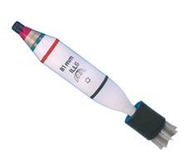
- Details of Application:

- Components Details

- Work piece Description: - Augmentic filling
- Weight: - 15 gms approx.
- Diameter: -81 mm

- Commercial:
Concept Image of Augmenting Charges

Augmenting Filler Machine

Sr. No | Description | Qty | Price in  INR/Each | Total Amount  In INR
1. | Conveyors | 1 SET | 42,80,000 | 42,80,000
2. | Vibro Platform | 1 SET | 42,80,000 | 42,80,000
3. | PLC & Sensors | 1 SET | 42,80,000 | 42,80,000
4 | Weighing Hoppers | 1 SET | 42,80,000 | 42,80,000
5. | Main Hopper & Extruder | 1 SET | 42,80,000 | 42,80,000
6. | Bowl Feeders & Linear Feeders System | 1 SET | 42,80,000 | 42,80,000
7. | Fabrication Assembly | 1 SET | 42,80,000 | 42,80,000
8. | Indexing Table Assembly | 1 SET | 42,80,000 | 42,80,000
9. | Installation Charges | 1 | 15,000 | 15,000
10. | Transportation Charges | 1 | 2,000 | 2,000
 | Total Amount |  |  | 42,97,000

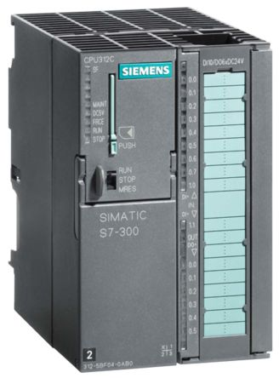
- Technical Specification:

- PLC & HMI
Make – Delta & Siemens

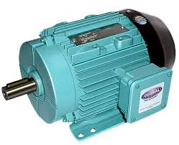

- Motor 1HP/ 2HP, Flameproof
Geared Motors

Make – Crompton/Bonfiglioli

Main Hopper screw motor

(steeper, flameproof with machinal break)

Make – NEFA / NEMA

- Bowl Feeders & Linear Feeders ( As per requirements)
Make – Nihva

- Conveyor system (As per requirement)
Make – Nihva

- Pneumatic Cylinder
Make -- SMC & FESTO

- Safety features

- In case of sudden power cut off, system will stand as it is until reset.
- FEA will be conducted for critical elements.
- Secondary Safety chain catch to prevent accidental drop off.
- Test Certificate will be provided for whole system.

- Terms and Conditions:
- Price  - P & F Charges  - Freight Notes  - Delivery  - Payment  - Insurance  - Tax: GST  - Validity  - Warranty | : Ex. Works Pune  : Included in above prices.  : Included in above price  : within 9-10 weeks from the date of receipt of confirmed purchase order, Advance Payment, Drawing approval.  :80% Advance along with Confirmed Purchase Order & Balance before dispatch.  : Extra as applicable.  : 28% on total supply value. (as applicable)  :15 days from the date of quotation  :12 Months from the date of supply.

With Best Regards
Pooja Badre
7709586333
NIHVA Technologies Pvt Ltd
Please feel free to Contact Mr. Mayur Derle on 7709209333 For any further Clarification in this Concern.

